Appendix C. Scientific Data Used to Develop the Framework

http://www.fda.gov/Food/ScienceResearch/ResearchAreas/SafePracticesforFoodProcesses/ucm094192.htm

Evaluation and Definition of Potentially Hazardous Foods

1. Determination of pH and water activity limits for TCS foods
To determine pH and water activity limits for TCS foods, as they are presented in the framework (see Chapter 8) the panel used data from the literature and from the results of the survey (see appendix B). Data for products with identified preservative systems were not included to assure that conservative data were used to determine limits. Professional judgement of the panel was used to omit unrealistic data. For example, studies using artificially high inoculum levels in laboratory media with no competitive microflora, using mild humectants (for example, glycerol) or acidulants (for example, HCl) were not used if results varied significantly with substantial data in food systems.
While numerous studies have been done on growth of foodborne pathogens, many studies do not report the pH and water activity of the growth medium. As a result, only limited data are available to study the interaction of pH and a_{w} on the growth of foodborne pathogens. The panel strongly encourages researchers to include pH and water activity data in scientific publications to assist the incorporation of data into analyses such as the one being performed here.

1.1. Spores
Data on water activity and pH interaction effects on growth or toxin production of foodborne pathogenic sporeformers are illustrated below. The lines indicate the parameter limits that the panel considered to develop the framework.
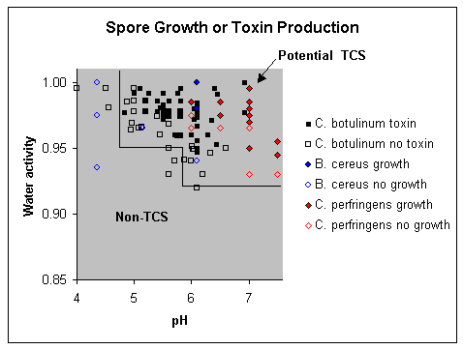

For foods that are treated to inactivate vegetative foodborne pathogens, the panel concluded that the following parameters effectively control the growth of sporeforming foodborne pathogens:
- pH = 4.6, or
- a_{W} = 0.92, or
- pH = 5.6 and a_{W} = 0.95
The panel believes that these parameters are conservative since numerous studies demonstrated lack of growth and/or toxin production above these levels. Products that fall in the non-TCS area should be considered in a "safe-harbor" that does not require time/temperature control. Products that fall in the potential TCS region may be stable depending on shelf life expectations, presence of preservatives, temperature, and other factors affecting growth (see Chapter 3). Challenge studies may be performed for foods in the high pH and a_{W} ranges and/or for those foods with extended shelf life expectations.
An equation to fit the data could also be used to identify pH and a_{W} combinations that would inhibit sporeforming pathogen growth; however, panel members believe that this would be more difficult to implement and/or communicate to non-technical users of the information.

1.2. Vegetative cells
Literature data on interaction of pH and water activity on control of vegetative pathogens is more limited than that for spore-formers. Published studies and modeling programs generally use broth media or foods with high a_{W} that are not near the minimum for growth. Studies conducted for short shelf life products are relevant to foodservice operators who are primarily interested in the potential for pathogen growth in hours or a few days; however, these studies may not be applicable to extended shelf life products.
The following data were considered in developing the framework for vegetative pathogen control, in addition to the minimum pH and a_{W} values for vegetative pathogen growth (see Chapter 3). However, the panel believes that intended shelf life must be considered in addition to pH and a_{W} in determining the need for time/temperature control. The lines indicate the parameter limits that the panel considered to develop the framework.

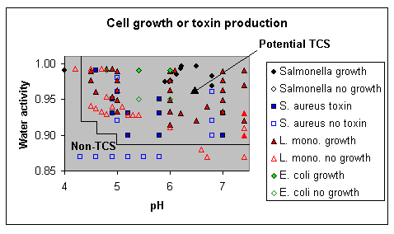

References
Asplund K, Nurmi E. 1991. The growth of salmonella in tomatoes. Int J Food Microbiol 13:177-82.
Baird-Parker TC. 1990. The staphylococci--an introduction. J Appl Bacteriol Symposium Suppl:1S-8S. (cited in ICMSF 1996a).
Barbut S, Tanaka N, Maurer AJ. 1986. Effects of varying levels of chloride salts on Clostridium botulinum toxin production in turkey frankfurters. J Food Sci 51:1129-31. (cited in ICMSF 1996a).
Bartsch AG, Walker HW. 1982. Effect of temperature, solute and pH on the tolerance of Clostridium perfringens to reduce water activities. J Food Sci 47:1754-5.
KC, Goepfert JM. 1970. Growth of Salmonella at low pH. J Food Sci 35:326-8.
Clavero MRS, Beuchat LR. 1996. Survival of Escherichia coli 0157:H7 in broth and processed salami as influenced by pH, water activity, and temperature and suitability of media for its recovery. Appl Environ Microbiol 62:2735-40.
Clavero MRS, Brackett RE, Beuchat LR, Doyle MP. 2000. Influence of water activity and storage conditions on survival and growth of proteolytic Clostridium botulinum in peanut spread. Food Microbiol 17:53-61.
KL. 1989. Combined effect of water activity and pH on inhibition of toxin production by Clostridium botulinum in cooked, vacuum-packed potatoes. Appl Environ Microbiol 55:656-60.
KA, Doyle MP. 1991. Relationship between water activity of fresh pasta and toxin production by proteolytic Clostridium botulinum. J Food Prot 54:162-5. P. 2001. Clostridium botulinum toxin production in various foods. Personal communication.
Hauschild AHW, Hilscheimer R. 1979. Effect of salt content and pH on toxigenesis by Clostridium botulinum in caviar [proteolytic strains only]. J Food Prot 43:245-8. (cited in ICMSF 1996a).
[ICMSF] International Commission on Microbiological Specification for Foods. 1996. Microorganisms in foods. Volume 5, Characteristics of microbial pathogens. London: Blackie Academic & Professional. 513 p.
JY. 1991. Clostridium botulinum growth and toxigenesis in shelf stable noodles. J Food Sci 56:264-5. KA, Chen JK, Lerke PA, Seeger ML, Unverferth JA. 1976. Effect of acid and salt concentrations in fresh-pack pickles on the growth of Clostridium botulinum spores. Appl Environ Microbiol 32:121-4. (cited in ICMSF 1996a).
Jakobsen M, Trolle G. 1979. The effect of water activity on growth of clostridia. Nord Vet-Med 31:206-13. CK, Woodburn M, Pagenkopf A, Cheney R. 1969. Growth, sporulation and germination of Clostridium perfringens in media of controlled water activity. Appl Microbiol 18:789-805. (cited in ICMSF 1996a). K-Y, Torres JA. 1993. Water activity relationships for selected mesophiles and psychrotrophs at refrigeration temperatures. J Food Prot 56:612-5. (cited in ICMSF 1996a).
McClure PJ, Roberts TA, Otto Oguru P. 1989. Comparison of the effects of sodium chloride, pH and temperature on the growth of Listeria monocytogenes on gradient plats and in liquid medium. Lett Appl Microbiol 9:95-9. (cited in ICMSF 1996a).
Miller AJ. 1992. Combined water activity and solute effects on growth and survival of Listeria monocytogenes Scott A. J Food Prot 55:414-18. (cited in ICMSF 1996a).
Notermans S, Heuvelman CJ. 1983. Combined effect of water activity, pH and sub-optimal temperature on growth and enterotoxin production of Staphylococcus aureus. J Food Sci 48:1832-5, 40.
Petran RL, Aottola EA. 1989. A study of factors affecting growth and recovery of Listeria monocytogenes Scott A. J Food Sci 54(2):45-60. (cited in ICMSF 1996a).
Raevuori M, Genigeorgis C. 1975. Effect of pH and sodium chloride on growth of Bacillus cereus in laboratory media and certain foods [rice and meat data only]. Appl Microbiol 29:68-73.
Razavilar V, Genigeorgis C. 1998. Prediction of Listeria spp. growth as affected by various levels of chemicals, pH, temperature and storage time in a model broth. Int J Food Microbiol 40:149-57.
Simpson MV, Smith JP, Dodds KL, Ramaswamy HS, Blanchfield B, Simpson BK. 1995. Challenge studies with Clostridium botulinum in a sous vide spaghetti and meat sauce product. J Food Prot 58:229-34.
Swanson KMJ. 2001. Clostridium botulinum toxin production in various foods. Personal communication.
Tienungoon S, Ratkowsky DA, McMeekin TA, Ross T. 2000. Growth limits of Listeria monocytogenes as a function of temperature, pH, NaCl, and lactic acid. Appl Environ Microbiol 66:4979-87.
[USDA] U.S. Dept. of Agriculture, Agricultural Research Service, Eastern Regional Laboratory. 2001. USDA Pathogen Modeling Program Version 5.1.

